Term | Simple Definition
Test KPI | A measurable value used to monitor testing performance and quality.
Pass Rate | Percentage of executed tests that passed.
Defect Density | Number of defects found relative to a defined software size.
Test Coverage | Percentage of the selected testing scope covered by testing.
Log Level | Indicates the importance of a log message.
Log File | A file that stores test or application execution information.

Technical Learning Report: Day 4
Date: October 4, 2026
Intern Name: Shekhar Singh Rawal
Subject: Test Metrics, KPIs & Python Logging

1. Objective
The objective of Week 5 Day 4 was to understand how test metrics, KPIs, and logging support test monitoring and control. The session focused on pass rate, defect density, test coverage, Python logging, log levels, and log files. Practical work was focused on applying logging to automation scripts and understanding how execution information can be collected and analyzed through meaningful metrics. The topic also aligned with ISTQB Chapter 5.3: Test Monitoring and Control.

2. Technical Breakdown

2.1 Test KPIs
Test KPIs (Key Performance Indicators) are measurable values used to monitor testing progress, quality, and effectiveness.
Common testing KPIs studied were:
- Pass Rate
- Defect Density
- Test Coverage
- Test execution results
- Testing trends
These metrics help a QA team and Team Lead understand the current quality status of an application.

2.2 Pass Rate
Pass Rate represents the percentage of executed tests that passed.
Pass Rate = (Passed Tests / Total Executed Tests) × 100

2.3 Defect Density
Defect Density represents the number of defects found compared with a defined size of the software.
Example:
20 defects / 2,000 lines of code
= 0.01 defects per line
This metric can help identify areas where defects are concentrated.

2.4 Test Coverage
Test Coverage indicates how much of the selected testing scope has been covered.
Example:
Requirements = 100
Requirements tested = 85
Coverage = 85%
Coverage was studied as a metric for identifying areas that may require additional testing.

3. Python Logging

Definition
Python's logging module provides a structured way to record information about program and test execution.
Instead of using only print() statements, logging allows messages to be categorized according to their importance.
Example:
import logging
logging.basicConfig(level=logging.INFO)
logging.info("Starting test execution")
logging.warning("Response is slower than expected")
logging.error("Login test failed")

Practical Work
Python logging was applied to automation testing concepts to understand how important test execution events can be recorded.
The logging approach was used to track events such as:
Test Started
↓
Test Action
↓
Test Result
↓
Failure / Error Information
This creates an execution trail that can later be used during debugging and root-cause analysis.

4. Log Levels
Different log levels were studied according to the importance of an event.
Level | Meaning | QA Example
DEBUG | Detailed debugging information | Locator or variable information
INFO | Normal execution information | Test started
WARNING | Unexpected situation that may not stop execution | Slow response
ERROR | An operation failed | Element not found
CRITICAL | Serious failure | Automation framework unavailable
Understanding log levels helps separate normal execution information from important failures.

5. Log Files
A log file stores recorded execution messages so they can be reviewed after testing.
Example:
test_execution.log
INFO - Test execution started
INFO - Opening application
INFO - Performing test action
ERROR - Element was not found

Practical Work
The concept of storing execution information in log files was practiced as part of automation logging. This provides a persistent record of what happened during test execution.
This is particularly useful when a test fails because the tester can review the recorded events to understand where the failure occurred.

6. Applying Logging to Automation Tests
The logging concept was connected with the automation tests developed during the previous days.
A simplified implementation was:
import logging
logging.basicConfig(
filename="test_execution.log",
level=logging.INFO
)
logging.info("Starting test")
try:
logging.info("Executing test action")
# Test execution
logging.info("Test action completed")
except Exception as e:
logging.error(f"Test failed: {e}")
The practical purpose was to understand how logging can complement Pytest and Allure reporting.
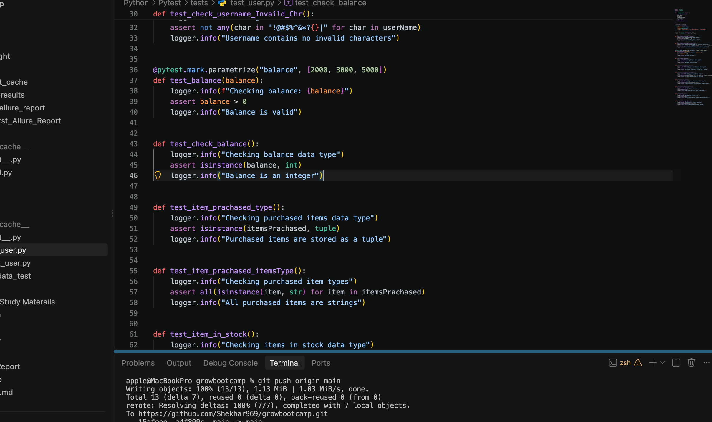
Other test metrics
 | QA Metric | Small Definition | Real-Life Example
1 | Defect Density | Defects found per unit of software size. | 20 defects ÷ 10 KLOC = 2 defects/KLOC
2 | Defect Arrival Rate | Number of new defects reported over time. | 15 defects ÷ 5 days = 3 defects/day
3 | Defect Severity Index | Measures the overall seriousness of defects. | 2 Critical, 3 High, 5 Medium → DSI = 5.5
4 | Defect Removal Efficiency (DRE) | Percentage of defects found before release. | 95 found, 5 escaped → 95% DRE
5 | Defect Leakage | Percentage of defects that reach production. | 5 production defects ÷ 100 total = 5% leakage
6 | Reopen Rate | Percentage of fixed defects that are reopened. | 5 reopened ÷ 50 fixed = 10%
7 | Test Case Execution Rate | Percentage of planned tests that are executed. | 180 ÷ 200 tests = 90%
8 | Test Pass Rate | Percentage of executed tests that pass. | 92 passed ÷ 100 = 92%
9 | Test Case Effectiveness | Measures how well tests find defects. | 8 defects ÷ 100 tests = 8%
10 | Test Case Productivity | Test cases created per unit of effort. | 40 tests ÷ 8 hours = 5 tests/hour
11 | Requirement Coverage | Percentage of requirements covered by tests. | 45 ÷ 50 requirements = 90%
12 | Code Coverage | Percentage of code executed by tests. | 8,000 ÷ 10,000 lines = 80%
13 | Risk Coverage | Percentage of high-risk areas tested. | 9 ÷ 10 critical areas = 90%
14 | Test Effort Variance | Difference between planned and actual effort. | 120 actual − 100 planned = +20 hours
15 | Cost per Defect | Average testing cost to find one defect. | $5,000 ÷ 100 defects = $50/defect
16 | Testing ROI | Financial benefit gained from testing. | $20K benefit, $10K cost = 100% ROI
17 | Automation Coverage | Percentage of tests that are automated. | 400 automated ÷ 500 = 80%
18 | Maintenance Effort | Time spent maintaining automation scripts. | 10 ÷ 50 hours = 20%
19 | Flaky Test Rate | Percentage of tests that fail inconsistently. | 4 flaky ÷ 200 tests = 2%
20 | Automation ROI | Financial benefit gained from test automation. | $3K monthly saving; $6K investment = 2-month recovery

7. AI-Assisted Activity
AI was included as part of the metrics-analysis activity.
A sample prompt used for this type of analysis was:
Analyse this test execution report and summarise key
quality metrics and risks.
The purpose was to understand how AI can help summarize:
- Test execution results
- Quality metrics
- Failure patterns
- Potential risks
- Release-readiness concerns
The AI output should be reviewed against the actual test results. AI-generated conclusions should not be accepted blindly because the tester remains responsible for validating the interpretation.

8. Practical Work Completed
The day's practical learning connected the concepts of Pytest, Allure, metrics, and logging from the previous sessions.
The work included:
- Studying how test execution results can be converted into meaningful KPIs.
- Practicing calculation and interpretation of pass rate.
- Understanding defect density and test coverage as quality metrics.
- Learning how Python logging can be added to automation scripts.
- Practicing different logging levels such as DEBUG, INFO, WARNING, ERROR, and CRITICAL.
- Understanding how log files preserve execution information for later investigation.
- Connecting logging with root-cause analysis of failed tests.
- Understanding the structure of an Excel/HTML test metrics dashboard.
- Studying how test trends can be used to monitor changes across executions.
- Reviewing how AI can analyze test execution reports and identifying the need to critique AI-generated results.

9. Key Findings & Best Practices
- Test metrics should provide useful information for monitoring testing progress.
- Pass rate should not be used alone to determine release readiness.
- Coverage helps identify areas that may still need testing.
- Defect metrics should be considered together with severity and business risk.
- Appropriate log levels make automation logs easier to analyze.
- Log files provide useful historical information during failure investigation.
- Structured logging can make root-cause analysis faster.
- Trends become meaningful when results from multiple executions are compared.
- AI can assist with metric analysis, but QA engineers must validate its conclusions.

10. Conclusion
Week 5 Day 4 focused on test monitoring, KPIs, metrics, and Python logging. The learning connected the previous Pytest and Allure work with practical test monitoring concepts. Pass rate, defect density, coverage, trends, logging, log levels, and log files were studied and connected to automation testing. The practical work demonstrated how structured execution information and meaningful metrics can help QA teams understand testing progress, investigate failures, and make better release-readiness decisions.

